|  |
| --- |
| colored transparent rectangle  PROJECT INTERIM REPORT #1 |

|  |
| --- |
| **PNEUMONIA DETECTION**  CAPSTONE PROJECT REPORT  by AIML Sep 19 B Group3 |

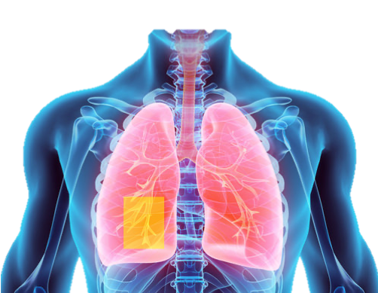

Contents

Project Background 1

Background2

Project Statement2

Notes on Chest X-Ray Images3

Exploratory Data Analysis 7

Data Report7

Basic Data Report7

DICOM Data Study9

Data Preparation14

Data Pre-processing and Augmentation14

Model Build and Evaluations16

Segmentation model16

Object Detection model18

|  |
| --- |
| PROJECT BACKGROUND |

|  |  |  |
| --- | --- | --- |
| BACKGROUND **PROJECT STATEMENT**  In this capstone project, the goal is to build a pneumonia detection system by locating the position(s) or zone(s) of inflammation in sampled patient Chest X-Ray(CXR) images like the ones shown below. The project explores a variety of deep neural network architectures to identify optimum detection via object detection as well as sematic segmentation methods.    In X-Ray images, tissues with sparse material, such as lungs which are full of air, do not absorb the X-rays and appear **black** in the image, indicating transparency. Dense tissues such as bones absorb X-rays, indicate opacity and appear **white** in the image. We’re detecting lung opacities in the images which is indicative of pneumonia. X-ray images in the dataset given are identified either as "N*ormal*" lungs or as pneumonia infected *"Lung opacity"* using annotation boxes via inputs from practicing radiologists. The "lung opacities" typically appear **grey** and "hazy" in X-ray images with partial transparency and with the lack of a clear boundary. The additional complexity in the dataset given is that there are also X-ray images where grey areas in lungs are not pneumonia related such as in the case of lung tumors that maybe cancer related or in some cases, chest cavity filled with fluid or even in the case of patients with heart enlargement. | | |
|  | | |
|  |  |  |

|  |
| --- |
| PROJECT BACKGROUND |

|  |  |
| --- | --- |
|  |  |
|  |

**CHEST X-RAY IMAGES (Notes from Dataset Visualization and Research on CXR Images)**

The lung infection or patient afflictions observed in the CXRs images are of many kinds. Many of them are not indicative of pneumonia and are in fact classified in our dataset as “Not normal / No lung opacities”. This extra third class of images had abnormalities on the image and oftentimes may mimic the appearance of true pneumonia. Let’s look at the various possibilities to understand our dataset fully and that will help us clean up and augment data going forward and thus enable eventually a more robust set of ML pneumonia detection models. Let’s 1st look at the CXRs belonging to *“Normal”* class which is associated with *“Target”*=0 in the dataset showing mostly black and clear lung air cavity with no grey zones to identify infections or abnormalities *(figure is code output)*

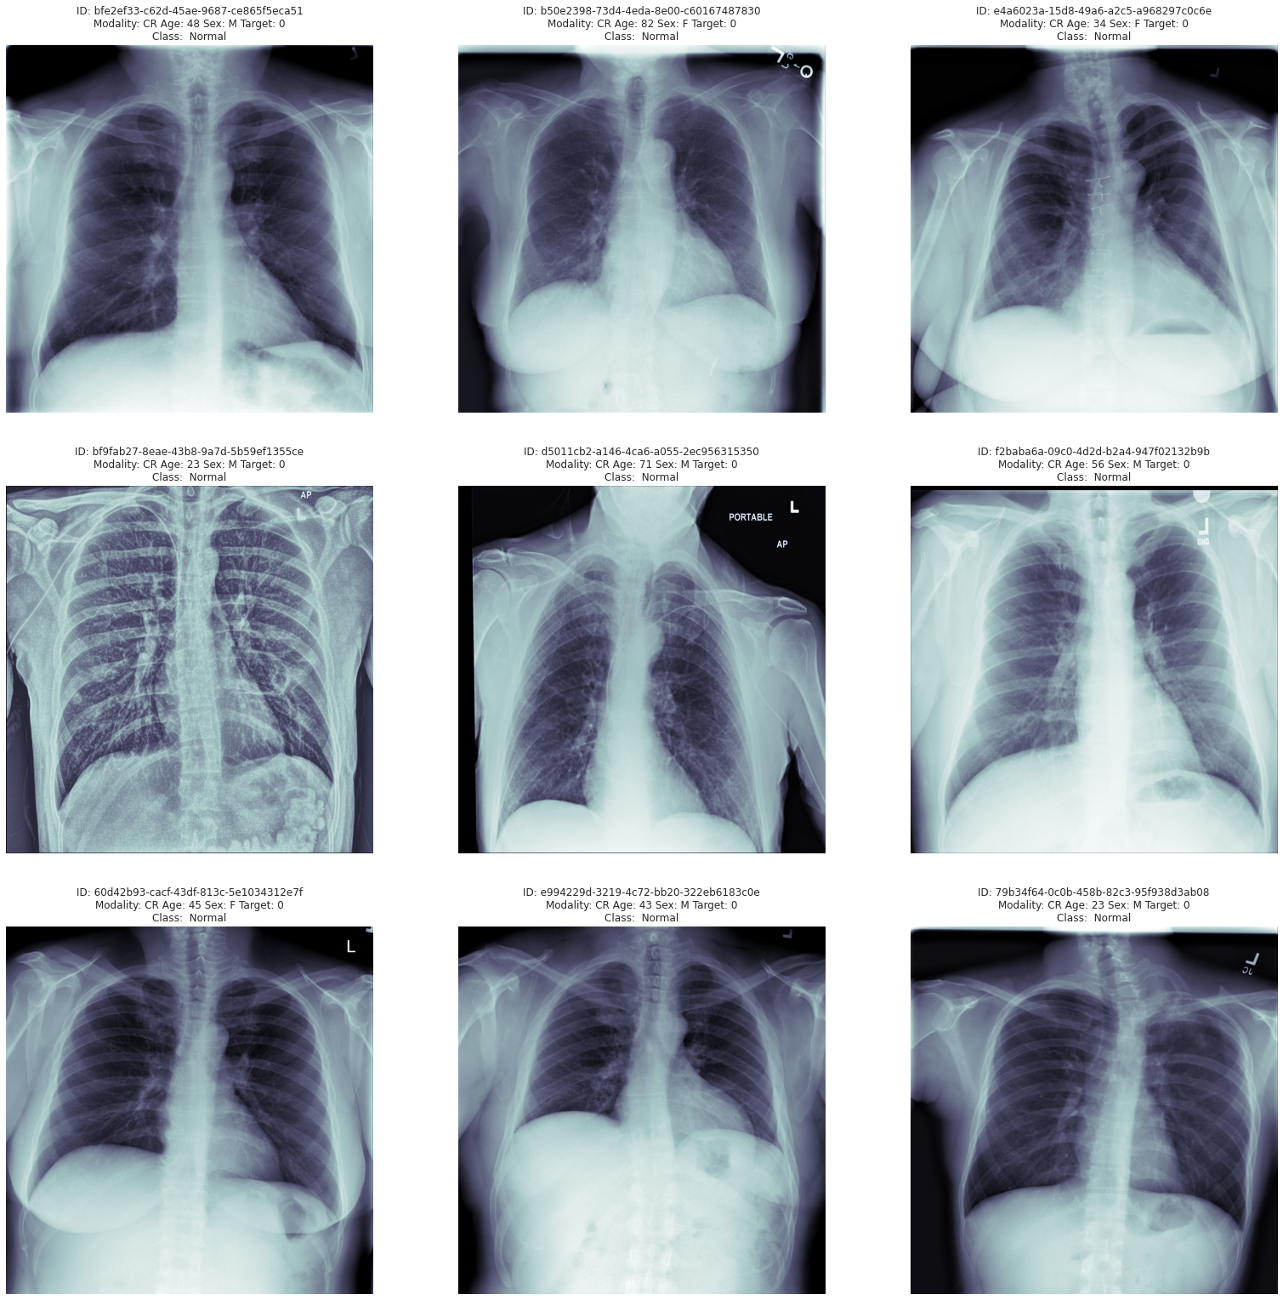

**CHEST X-RAY IMAGES (contd.)**

|  |
| --- |
| PROJECT BACKGROUND |

Let’s now look at the CXR images identified as *“Lung opacity”* class and *“Target”* =1 in given dataset and with the box annotations to show the zones where lung opacities or grey areas are observed. Note that the grey areas are mostly hazy and with no shape or clearly defined boundaries (figure below is from code output)

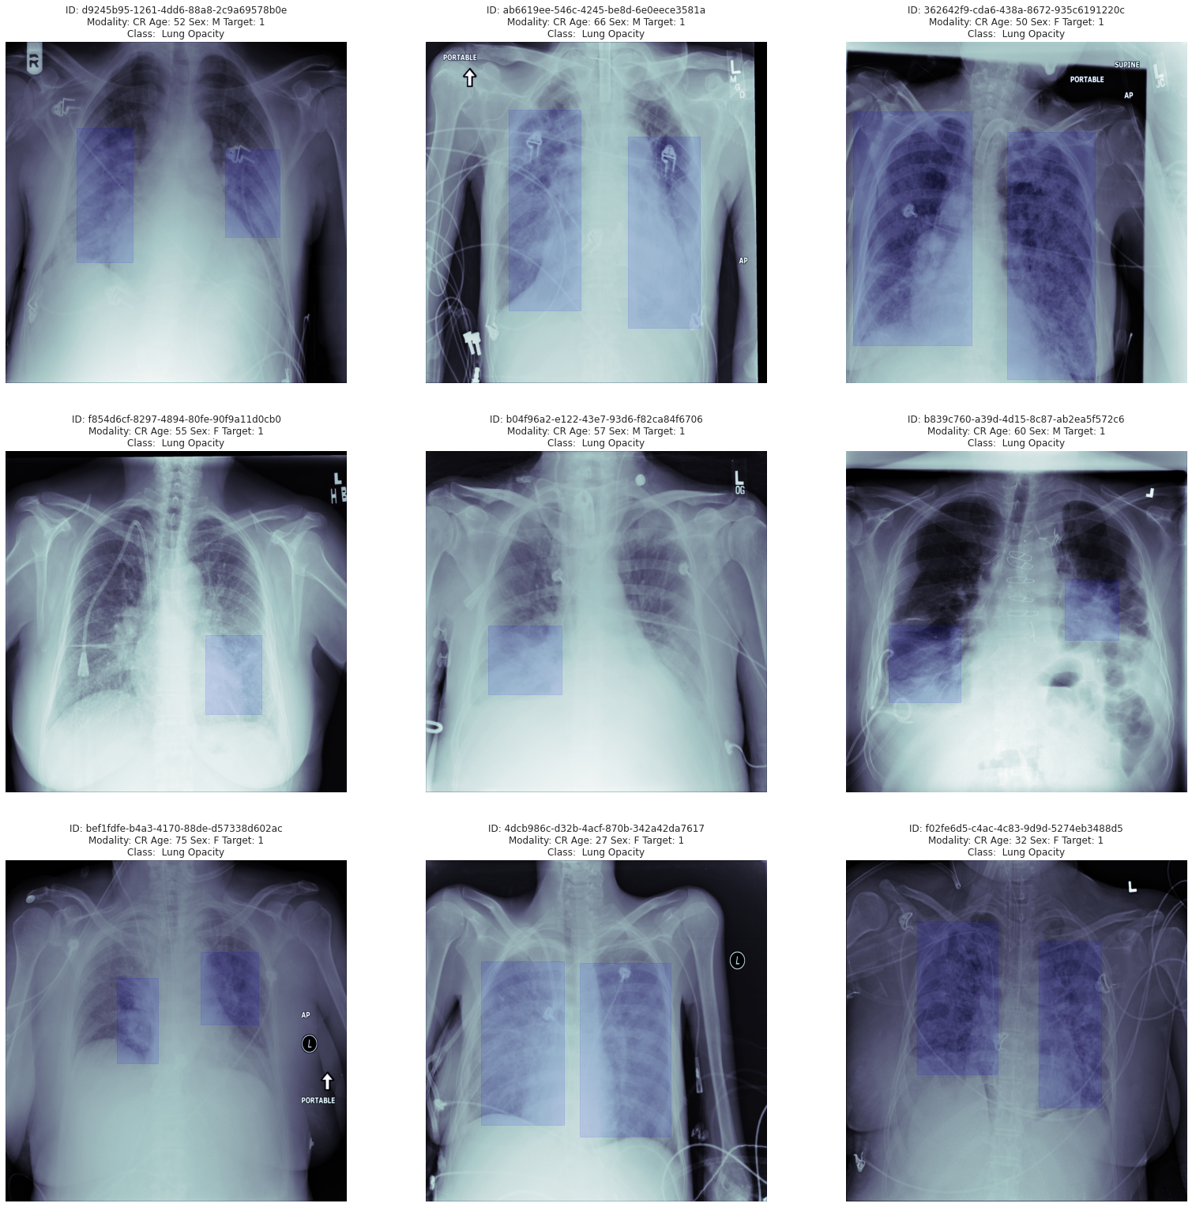

|  |
| --- |
| PROJECT BACKGROUND |

**CHEST X-RAY IMAGES (contd.)**

Let’s now take a closer look at image comparison below between a typical *“Lung opacity”* CXR sample image indicating pneumonia and an image type of CXR with abnormalities observed in the form of lung nodules and masses which could be indicative of tumour / cancer. Referring to the CXR image on the right below, the observed grey segments within the lung cavity space are identified as lung nodules/masses and have more well defined shapes (oval) and boundaries (figure is from research). This (CXR on right) would be not be identified as normal nor as pneumonia but belonging to the 3rd class:*“Not Normal / No Lung Opacity”.* Contrast this with the image on left where the *“Lung opacity”* grey areas are hazy and with no shape or boundaries. These could be potentially confusing for the image segmentation or object detection algorithm we define and need perhaps adequate feature extraction (pointing to deep layered network architecture?)

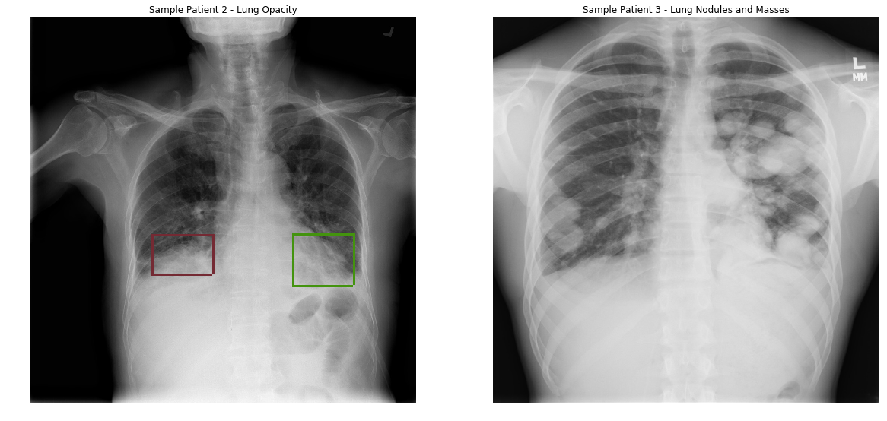

**Note: Figure above and below are from Research**

|  |
| --- |
| PROJECT BACKGROUND |

More examples of “non-Pneumonia” abnormalities are shown in the 2 figures below where the images on the right in each figure show abnormal CXRs and are contrasted vs normal CXRs which are shown on the left side of the figure. In the 1st figure below, the image on right shows actually a CXR with chest cavity filled with fluid. In the 2nd image, the grey areas appearing to infringe into lung cavity zone due to an enlarged heart and vascular markings. Obviously in all above cases, no Pneumonia is diagnosed.

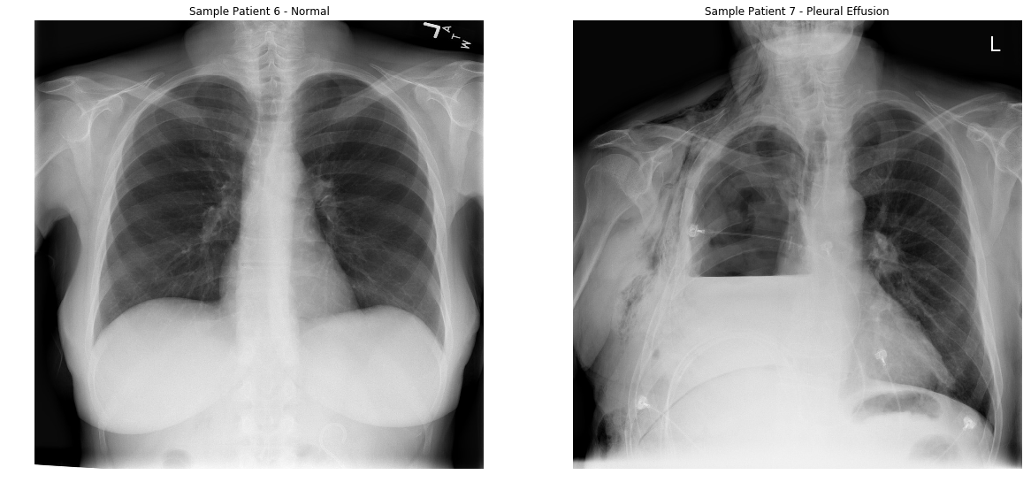

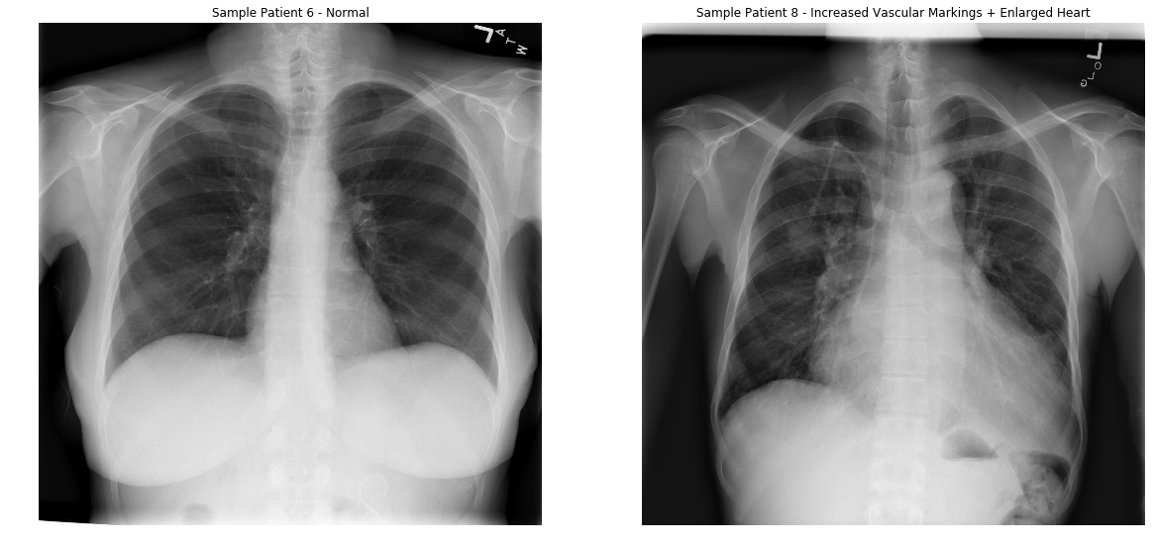

We thus need to be careful in data preparation and also augmentation for training our models while segregating the pneumonia patient CXR images vs the normal CXRs.

|  |
| --- |
| EXPLORATORYDATA ANALYSIS |

**DATA REPORT**

The X-ray medical images are stored in DICOM format files (*.dcm). They contain a combination of header metadata as well as underlying raw image arrays for pixel data.

Details about the data and the dataset files are extracted from the link,

<https://www.kaggle.com/c/rsna-pneumonia-detection-challenge/data>

**BASIC DATA SUMMARY**

* Images for testing and training are in the folders: stage_2_train_images and stage_2_test_images.
* Training data 1: "stage_2_train_labels.csv" contains the box annotation coordinates and the targets (1-for pneumonia patient and 0-not pneumonia)
* Training data 2: "stage_2_detailed_class_info.csv" contains detailed information about the classes in the training set ("Normal", "Lung opacities" and "No lung opacity / Not Normal" classes)
* Both metadata from CSVs are loaded into dataframes and observed to have 30227 patient samples info obtained from CXRs of 26684 unique patients. The dataframes are later merged into one with ‘patient id’ as the common identifier.
* The “train_labels” dataframe is seen to have 6 columns with:
  + 4 numeric real data corresponding to rectangle location and dimensions of the annotated box identified for each pneumonia patient,
  + 1 target class column which is a classifier for patient as pneumonia patient or not (1-yes / 0-no)
  + 1 column for the ‘patient id’ object data
* The “class info” dataframe has the ‘class’ identified for all the CXR images:
  + 3 classes observed: “Normal”, “Lung Opacity” and “No Lung Opacity / Not Normal
* The ‘training labels’ data has 68.4% null data for the box identifier of patient CXR which should ideally correspond to number of patients identified with no pneumonia. This is confirmed thru the class distribution count plot below

|  |
| --- |
| EXPLORATORYDATA ANALYSIS |

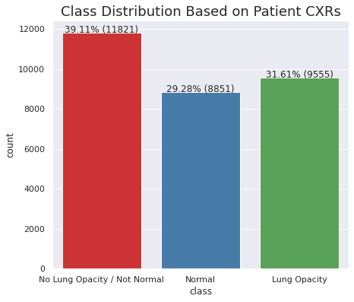

* The non-Pneumonia patients (blue + red bars in above figure) add up to 68.4% which exactly corresponds to the above mentioned Null data in the dataframe.
* Let’s look at the data distribution across the “Normal” and the “Lung Opacity” classes (see fig below from code output). It looks more balanced data across the above 2 classes. We could consider just these classes for initial training of our models before adding samples from the 3rd class *(“Not Normal / No Lung Opacity”)*

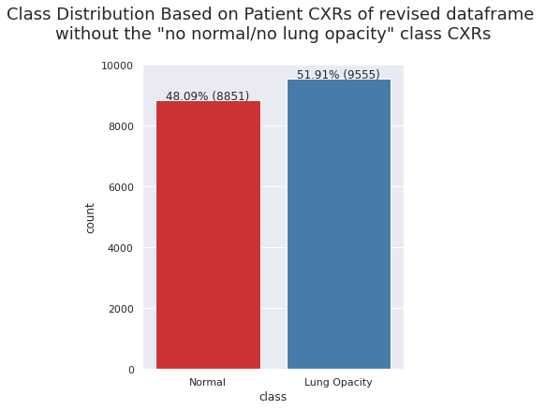

|  |
| --- |
| EXPLORATORYDATA ANALYSIS |

**Table: Class Distribution of Unique Patient Records**

|  |  |  |  |  |
| --- | --- | --- | --- | --- |
| Target | Class | CXRs_count per patient | Total count | % |
| 0 | No Lung Opacity / Not Normal | 1 | 11821 | 44.3% |
| 0 | Normal | 1 | 8851 | 33.2% |
| 1 | Lung Opacity | 1 | 2614 | 9.8% |
| 1 | Lung Opacity | 2 | 3266 | 12.2% |
| 1 | Lung Opacity | 3 | 119 | 0.4% |
| 1 | Lung Opacity | 4 | 13 | 0.1% |
|  |  | TOTAL | 26684 | 100% |

* Some of the Pneumonia patients with lung opacities identified have multiple CXR records as shown by the table above. ~56% of the Pneumonia patients have atleast 2 CXRs taken.
* ~78% of the patients sampled are either normal or have abnormalities in their CXRs that are not Pneumonia related. These patients have just one CXR taken based on the dataset sample
* We need to identify the Pneumonia patient with multiple CXR samples when we consider masks for training segmentation models

Based on the annotated box centres to denote lung opacities indicated by figure below, most of the infected zones seem to be centred around the range (Xc=200 to 400, Yc= 400 to 700) on the left and the range (Xc=600 to 800, Yc=400 to 700) on the right lung. The symmetry is intuitive since both lungs are equally vulnerable to Pneumonia and will have lung opacities accordingly. This is useful info when considering image data pre-processing for resizing, trimming etc (fig. below is extracted from code output)

|  |
| --- |
| EXPLORATORYDATA ANALYSIS |

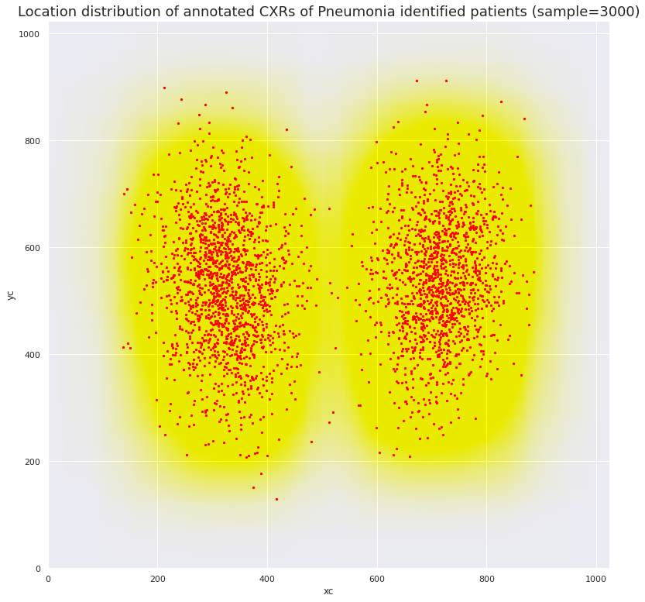

|  |
| --- |
| EXPLORATORYDATA ANALYSIS |

**DICOM Data Study: Age Based Statistics**

|  |
| --- |
| EXPLORATORYDATA ANALYSIS |

* A larger proportion of patients (~46%) are from the age group 40-60
* A few outliers are seen (5) well above the age of 100 (max=155!) and the age is capped off at 105 for these outliers during clean up

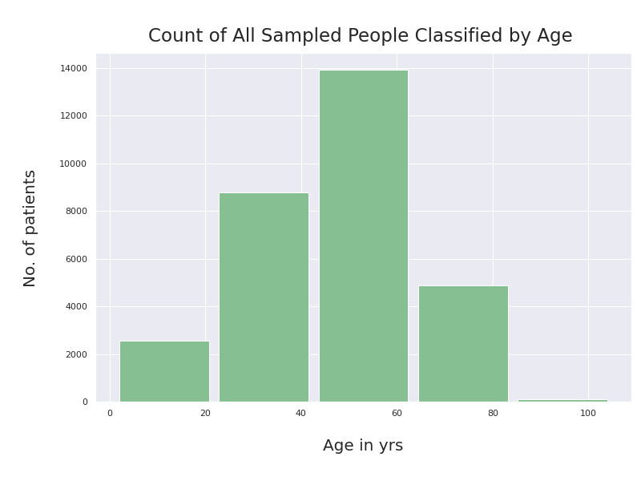 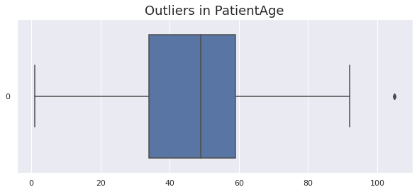

|  |
| --- |
| EXPLORATORYDATA ANALYSIS |

**DICOM Data Study: Age Based Statistics (contd.)**

* By comparing the 2 bar plots (below here and above in previous page), A distinctly higher percentage (~56%) of patients sampled in the age group 60-80 are showing lung opacities in their CXRs indicating a relatively higher propensity for Pneumonia infection in this age group.
* In other age groups, the %age of patients sampled showing Pneumonia infection are relatively much smaller (<25%)

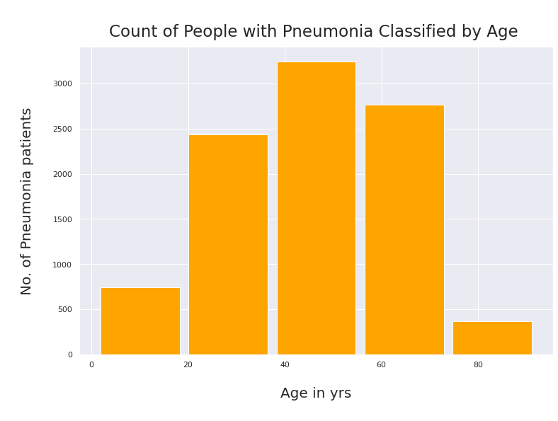

|  |
| --- |
| EXPLORATORYDATA ANALYSIS |

**DICOM Data Study: Gender Based Statistics**

* A higher %age of males (~56%) are sampled in the dataset indicative perhaps of the higher incidence of such illnesses in males
* The proportion of patients infected by Pneumonia is the same across males or females (~32% or ~1/3rd of patients sampled)

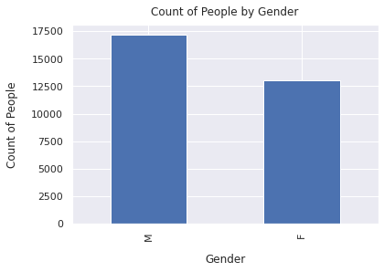

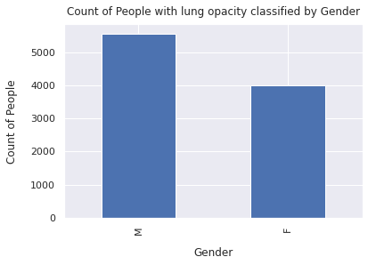

|  |
| --- |
| DATA PREPARATION |

**DATA PRE-PROCESSING AND AUGMENTATION**

* Initially, data pre-processing is done followed by some augmentation to facilitate robust inputs for CNN architecture deployment for both semantic segmentation as well object detection based initial models.
* Image data is loaded by batch sampling from the entire dataset initially and to train the initial models. Later, we will use modified datasets for model iterations.
* Locations which are annotated on the CXRs as rectangular boxes to identify *“Lung Opacity”*, which is indicative of Pneumonia infection in patients are now loaded into a dictionary with *“patientId”* as key from the “train_labels” csv file.
* For multiple box locations per patient ID, location lists with integer values (converted from initial float dtype) of the box location + dimension are appended to the single “patientId” key in the dictionary for use in a data generator for model training.
* Image masks pixel array are then developed based on the above box location dictionary and the image data towards semantic segmentation.

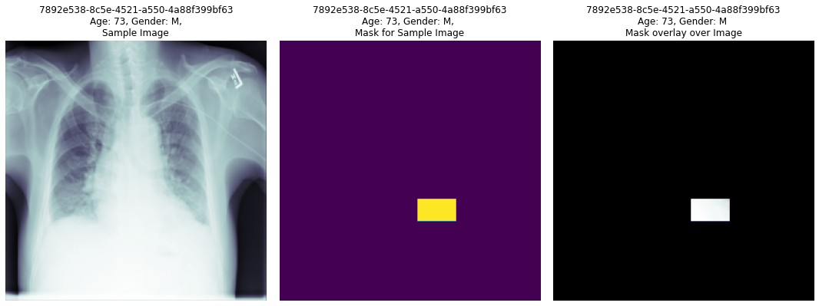

**(Figure is from the code)**

**DATA PRE-PROCESSING AND AUGMENTATION (contd.)**

* Above figure which is from the code below randomly picks a Pneumonia positive "PatiendId" (Target=1) from the dataframe and plots the image, its mask for

segmentation and also the mask overlay over the image using bitwise AND operation on the image pixel and mask pixel values for each image pixel.

* Image is resized to 1/4th from original (1024x1024) to (256x256) pixel size as well as another set with resizing to (128x128).

|  |
| --- |
| * DATA PREPARATION |

* Half the image samples loaded are flipped horizontally (about vertical axis) to augment the data samples for training input.
* Additional dimension is added for the channel to get the correct input size for CNN architecture based model deployment.
* The 26684 samples are split into training and test sets in the ratio 90:10, training set having 24124 samples and validation (test) set having 2560 samples. Of these 26684 patient total samples, only 6012 are identified having Pneumonia (~23%) which causes an imbalanced dataset to begin with. This will be fixed by starting with a dataset without the “Not Normal/ No Lung Opacity” class data records. This will provide a more balanced dataset between normal and Pneumonia patients.
* We will do this after building a CNN segmentation model and testing it initially with a small data sample of 500 for training and 100 for validation from the original sample set

**MODEL STRATEGY**

* A U-Net architecture based segmentation model is built and output monitored in terms of loss, accuracy% and IOU metric and tabulated
* Similarly, an Object detection model is also build based on Mobile-net architecture
* Initial models built are based on aforementioned basic data pre-processing and basic augmentation using a horizontal flip.
* Image resizes of (128x128)&(256x256) are used for segmentation model and (224x224) for the object detection model
* Models are built and checked based on small data samples in the case of both models; 700 for segmentation and 2875 samples for the object detection case.
* The models are trained on a train and test split of 90:10. A more ideal 85:15 will be pursued for future iterations
* The models are being setup for multiple future studies ranging from ChexNet, DenseNet, ResNet to MobileNet and RetinaNet variations.

|  |
| --- |
| MODEL BUILD & EVALUTATION |

**SEGMENTATION MODEL**

* A U-Net based deep 23-layer architecture is initially tried with following network layout as shown in figure below. The initial image resize from (1024,1024) to (128,128) is used although (256,256) would be more appropriate and would be used for future architecture and data tuning to improve validation accuracy.
* The model is trained with a small data generator sample size of only 500 images for training and 100 for testing and the results are tabulated below in figure to indicate that the segmentation model is working fine. The larger sample sizes are being tried out by expanding colab resources currently.



|  |
| --- |
| MODEL BUILD & EVALUTATION |

**Segmentation Model Architetture based on U-Net**

**SEGMENTATION MODEL MONITORING METRICS**

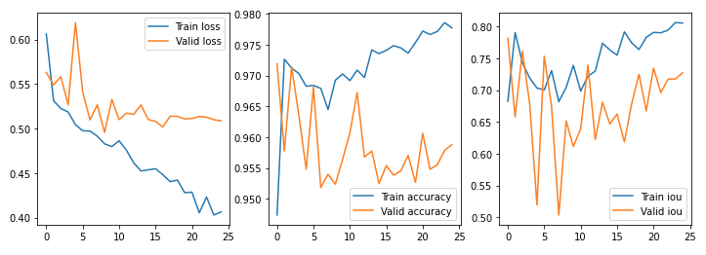

* Each Image has overlay of actual (blue box) and predicted (red box) for 16 test samples below. 7 samples show pneumonia prediction with boxes and except for one image, the samples show good correlation between blue and red boxes (mean validation IOU of ~0.7 for test samples)

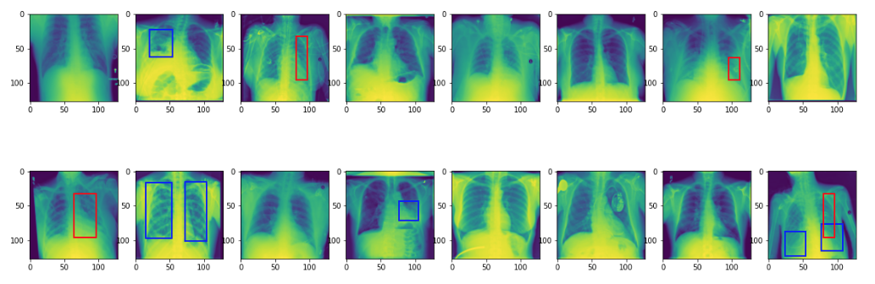

|  |
| --- |
| MODEL BUILD & EVALUATION |

|  |
| --- |
| MODEL BUILD & EVALUATION |

**OBJECT DETECTION MODEL**

* Using **MobileNet V2** and transfer learning with the architecture given below.
* Trained with 1725 samples and tested with 1150 samples (60:40 split) for initial model evaluation.
* Initial model built yielded dice coefficient of 0.31 and an accuracy of

